主要处理逻辑：
在上位机创建一个服务端与客户端，服务端用于接收Hexcal的连接，客户端用于连接运动平台控制器；针对正常Hexcal的补偿过程，将过程中交互的指令信息进行解析，下发给控制器的指令转换为控制器的运动指令，返回hexcal正确的返回信息，确保补偿可以顺利执行。
- 创建服务端：
经过测试发现，Hexcal只支持固定的控制器的补偿，控制器的IP地址与端口号是不可设置的，需要设置一个虚拟的IP地址100.0.0.1与端口号1234来与Hexcal进行信息交互。
具体的实现就是在电脑上增加一个DC的IP地址与端口号，同时确保监听该端口号，确保hexcal可以找到该ip，然后正常连接监听端口即可
- Hexcal补偿过程：
补偿过程主要是指令的转换，需要转换的指令有：
From Hexcal：CMMTYP
To Hexcal：CMMTYP MA 22815,FDC V51.04,3 4 3,0
含义：
From Hexcal：VERSION
To Hexcal：00-000-000-00000 FDC V51.04.0000 DATE: 12/21/22 TIME: 12:50:55
含义：
---------------------------------------------------------------------------
From Hexcal：^B
To Hex：READY 或BUSY
含义：查询状态
---------------------------------------------------------------------------
From Hexcal：SHOW MAXSTROKESW
To Hex：MAXSTROKESW 233.200000,346.500000,15.100000,0.000000,0.000000,0.000000,0.000000
含义：最大行程
---------------------------------------------------------------------------
From Hexcal：SHOW MINSTROKESW
To Hex：MINSTROKESW -68.800000,-55.500000,-286.900000,0.000000,0.000000,0.000000,0.000000
含义：最小行程
---------------------------------------------------------------------------
From Hexcal：SHOW MAXVEL
To Hex：MAXVEL 300.000000,300.000000,300.000000,0.000000,0.000000,0.000000,0.000000,0.000000
含义：
---------------------------------------------------------------------------
From Hexcal：SHOW MAXACC
To Hex：MAXACC 300.000000,300.000000,300.000000,0.000000,0.000000,0.000000,0.000000,0.000000
含义：
---------------------------------------------------------------------------
From Hexcal：SHOW TEMPCOMPTYPE
To Hex：TEMPCOMPTYPE 1
含义：温度补偿 >1表示支持温度补偿
---------------------------------------------------------------------------
From Hexcal：READTP 整数
To Hex：READTP 0.000000
含义：
From Hexcal：SHOW SENSWKP
To Hex：X_ SENSWKP 4,0,0,0,0,0,0,0,0,0,0,0,0,0,0,0
含义：
---------------------------------------------------------------------------
From Hexcal：SHOW X_SENSAXIS
To Hex：X_SENSAXIS 6,0,0,0,0,0,0,0,0,0,0,0,0,0,0,0
含义：
---------------------------------------------------------------------------
From Hexcal：SHOW Y_SENSAXIS
To Hex：Y_SENSAXIS 2,0,0,0,0,0,0,0,0,0,0,0,0,0,0,0
含义：
---------------------------------------------------------------------------
From Hexcal：SHOW Z_SENSAXIS
To Hex：Z_SENSAXIS 7,0,0,0,0,0,0,0,0,0,0,0,0,0,0,0
含义：
---------------------------------------------------------------------------
From Hexcal：SHOW MOVPAR
To Hex：MOVPAR 300.000000,300.000000,300.000000,0.000000,0.000000,0.000000,0.000000,0.000000,0.000000,0.000000,0.000000
含义：
---------------------------------------------------------------------------
From Hexcal：MOVPAR 300.0,300.0,300.0,0.0,0.0,0.0
To Hex：%
含义：设置速度 xyz轴的速度
---------------------------------------------------------------------------
From Hexcal：SHOW MAXVEL
To Hex：MAXVEL 300.000000,300.000000,300.000000,0.000000,0.000000,0.000000,0.000000,0.000000
含义：
---------------------------------------------------------------------------
From Hexcal：SHOW ACCEL
To Hex：ACCEL 1000.000000,1000.000000,1000.000000,0.000000,0.000000,0.000000,0.000000,0.000000
含义：加速度
---------------------------------------------------------------------------
From Hexcal：ACCEL 1000.0,1000.0,1000.0
To Hex：%
含义：设置加速度
---------------------------------------------------------------------------
From Hexcal：PRBPIN 0.000000,0.000000,0.000000,0.000000,0.000000, 0.000000, 0.000000,0.000000,0.000000,0.000000,0.000000, 0.000000
To Hex：%
含义：测头偏置
---------------------------------------------------------------------------
From Hexcal：ENABLE TEMP
To Hex：%
含义：
---------------------------------------------------------------------------
From Hexcal：WKPPAR 20,0.0000115,20
To Hex：%
含义：
---------------------------------------------------------------------------
From Hexcal：SCLTMP
To Hex：%
含义：
---------------------------------------------------------------------------
From Hexcal：MOVABS 167.553848,-55.400002,-208.548203,0.000000
To Hex：%
含义：移动
---------------------------------------------------------------------------
From Hexcal：GETPOS
To Hex：POS 167.553898,-55.400421,-208.548678,0.000000,0.000000,0.000000,0.000000
含义：显示位置
---------------------------------------------------------------------------
From Hexcal：SHOW ESTOP
To Hex：ESTOP FALSE
含义：
一些常规指令如下图可以使用固定的返回指令，其他的运动以及GETPOS指令可以返回实际的位置
“=”左边为Hexcal会下发的指令，右边为需要返回的指令
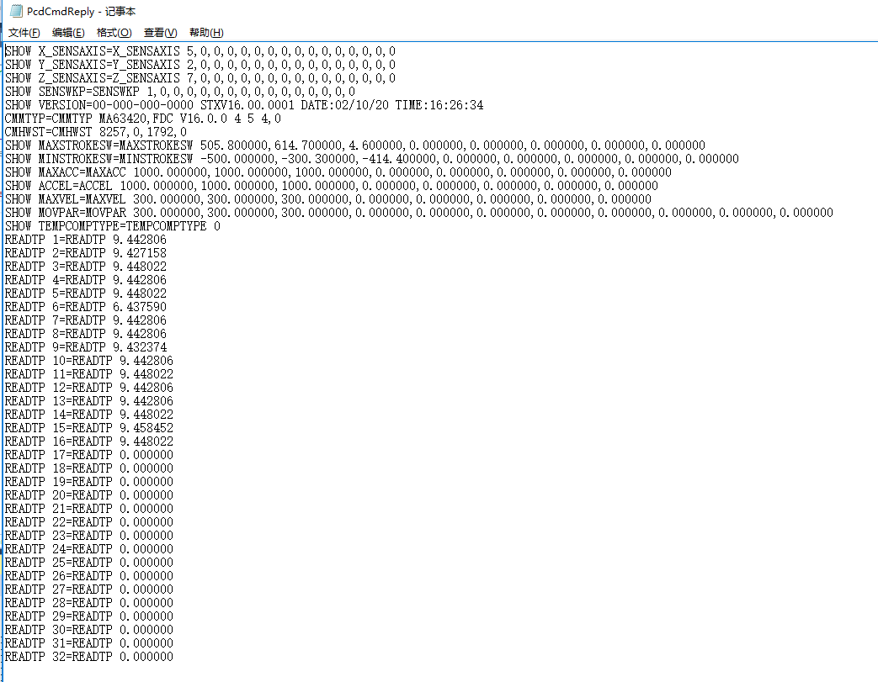
- 补偿过程的使用
Hexcal生成的补偿文件为.cmp格式的文件；
使用该文件需要用另一个软件将该文件转换成.dat格式的文件；

生成的.dat，可以给metus直接使用。

